Our top five restaurants of 2015
Brian Bernier, for Sheboygan Press Media 10:09 a.m. CST December 16, 2015
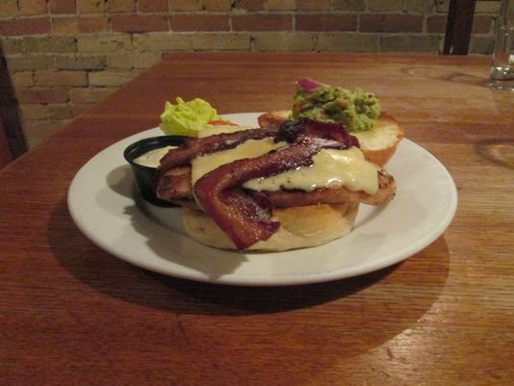Buy Photo
The grilled chicken sandwich, which features an all-natural oak-grilled chicken breast with bacon, guacamole, Havarti cheese, lettuce, tomato and tomatillo mayonnaise, was among the menu items during a recent visit to Field to Fork in Sheboygan.(Photo: Brian Bernier/For Sheboygan Press Media)Buy Photo
1695 CONNECTTWEETLINKEDINCOMMENTEMAILMORE
I can’t believe we’re already looking at the end of 2015. The year was exciting with new food sensations and creations that I was able to experience almost every week.
In choosing my top restaurants for this last year, there were a few things that had to happen in my dining experience.
When I walk into a restaurant I look at the ambiance. Does it look like the guests are having a great time and enjoying their food? Does the restaurant flow in its décor and complement the menu.
Does the menu show off the chef’s originality? Are the flavor combinations exciting and mouthwatering.
Are the plates prepared so that even before the first bite goes into your mouth you can’t wait to taste the entrée?
From where does the restaurant source its food? Do they take extra care buying local, organic or even growing some of their own food?
And, finally, are the staff prepared to answer questions about specials or other menu items? Do they strive to make your dining experience one that you will remember with their service?
These five restaurants (listed in no particular order), met my criteria, and scored highest:.
Field to Fork Café and grocery, Sheboygan
This downtown Sheboygan spot is where Chef Stefano Viglietti strives to always bring fresh organic produce, meat and dairy products into the restaurant. The flavor combinations of their sandwiches and salads are outstanding.
If you are looking for a unique breakfast or lunch, you can’t go wrong dining here. I have had many of their homemade soups, burgers, sandwiches and tasty eggs Benedict for breakfast. I have never walked away dissatisfied, and the service has always been excellent. Field to Fork also has a fresh juice bar to accompany any of your breakfast or lunch selections.
The Stilt House, Cedarburg
Owner Gordon Goggin brings small plate dining to a new level at this Cedarburg gastro bar.
Even though I dined there almost four months ago I can still taste the lobster BLT&E, which was topped with a fried egg. I have recommended this original small plate to many people. We also dined on portobello mushroom caps. This tasty melt-in-your-mouth small plate consisted of portobello mushrooms stuffed with a three cheese blend and drizzled with a balsamic glaze.
The soup offered the night we dined was lobster bisque. Too many restaurants don’t get this recipe right. Theirs was outstanding.The Stilt House also offers a great selection of craft beers and wine.
Lino Ristorante, Sheboygan
This South Pier restaurant celebrated its fifth year in business in 2015. I can understand why, you can always find Lino Autiero at the front of the house greeting guests and making sure that they feel like they just walked into a restaurant in Italy.
Lino’s son, Marco, is in the kitchen, serving sixth generation recipes like fettuccini con L’ Aragosta e Zafferano. (lobster fettuccini) or a sweet scallop recipe paired with creamy orzo that was on special the night we dined. Lino’s also serves one of my favorite appetizers, beef carpaccio, along with many other Italian favorites.
The antipasto table is exceptional and the open air kitchen is so clean it looks like it has been open two days, not one that has been open five years.
When touring the restaurant, I noticed that there were no microwaves and not a freezer to be found. Lino believes that freezing food subtracts flavor. That is why they make all their bread, desserts and almost all their pasta in house. Lino’s goal is “if it comes in today, it is served today”.
Cedar Lodge Restaurant, Malone
The next restaurant on my list for 2015 can be found in Malone near the eastern shore of Lake Winnebago. The Cedar Lodge Restaurant was my favorite supper club this year.
Dale and Candi Bothe make sure that when you dine at the Cedar Lodge you will not leave hungry. They also make sure the food you eat is the best quality available. They buy food from Park Ridge Organics in Fond du Lac and from local vegetable and mushroom growers. They also have 10 raised bed garden plots used to supply the freshest ingredients.
Entrees include your protein, starch and vegetables and your choice of soup or salad, and fresh baked fritter or fruit. And in traditional supper club fashion, they serve warm bread and blueberry muffins before dinner.
The fritters remind me of the French beignets that are served in Louisiana in the French quarter. They were so good I ordered another round for dessert.
The Cedar Lodge is known for hand cut steaks that tasted like something you’d find in Chicago. The tenderloin Oscar we ate, was outstanding and delicious with large lump crab and hollandaise sauce. My broiled seafood combo had a 4- to 6-ounce lobster tail, broiled shrimp and two large sea scallops. The seafood was succulent and sweet.
Koehrings Grand Central House, Kiel
My final choice this year is Koehrings Grand Central House. Fred Lubeley and Connie Brost make sure all the qualities that you love to find in a restaurant are wrapped up into this 19th century Victorian hotel.
All diners are served a cup of fresh chicken broth to start. Your entrees are served on white lace tablecloths, making sure everyone feels like they are at a special event. The flatware and all serving dishes are antiques.
Koehrings Grand Central House specializes in comfort food. Entrees like the surf and turf special and the chicken pot pie that we ate can’t be found in southeastern Wisconsin.
If you don’t see one of your favorites on this list, let me know who to visit in 2016.
Brian Bernier aka Chef Bernie, is a private in-home chef, organic farmer and food blogger, who lives in Sheboygan. He can be reached at Brian@BerniersBistro.com. Visit his website at FreshStepFood.com.

For more information
Field To Fork Café: 511 south 8th street Sheboygan Wisconsin, www.fieldtoforkcafe.com or 920-694-0322
The Stilt House: W62 N630 Washington avenue Cedarburg Wisconsin, www.stilthousegastrobar.com or 262-618-4889
Lino Ristorante: 422 south pier drive Sheboygan, www.linoitalia.com or 920-457-5200
Cedar Lodge: N10872 Hwy 151 Malone Wis., www.thecedarlodge.com or 920-795-

